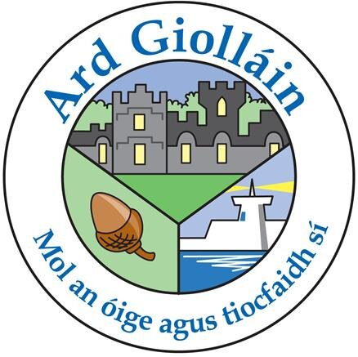

ARDGILLAN COLLEGE
OUR SELF-EVALUATION REPORT (2018-19) & IMPROVEMENT PLAN (2019-20)

In the last year, we have looked at teaching and learning in our school to find out what we are doing well. This is what we discovered:
- Uptake of Higher Level in State Exams is strong across subject departments
- Subject departments are embedding literacy, numeracy and assessment for learning strategies
- A caring and supportive staff, who are interested in student well-being, as well as academic achievement.
- Good discipline and enthusiastic, approachable teachers.
- A broad balanced curriculum, with a variety of subject choice in Transition Year and for Leaving Certificate.
- Excellent collaboration among staff within subject departments and policy groups. Very good subject planning. Good practice in marking.
- Sharing good practice amongst staff.
- Effective Droichead programme running.
- Strong Pastoral structures and SEN structures in place.
- Good availability of ICT (classroom PC’s, teacher work area, computer rooms, staff iPad, class sets of iPads for student use).
- Standardised exam cover sheet for feedback in place.
- Subject awareness weeks continued and encouraged.
- Afterschool clubs/groups continued and encouraged.
- Parental support for the school is strong. 98% of parents agree with the statement: ‘Overall, I am happy with the school’. 95% pf parents agree with the statement: ‘The school is well run’

This is what we did to find out what we were doing well, and what we could do better:
- Received Incidental inspection verbal feedback (2nd April 2019).
- Junior and Leaving Certificate Results Analysis Document (including 5-year trends). Using PDST tool for analyzing Junior and Leaving Certificate results.
- Parents qualitative survey
- Staff qualitative and quantitative survey.
- TEL policy group meetings. Creation of a Digital Learning Plan in line with PDST recommendations.
- Meetings with the Student Council. Student Council undertook student interests survey.
- Meetings with the Head Boy and Head Girl.
- Feedback from teachers on Droichead programme. 85% of teachers report that ‘New teachers are well supported when they start work in the school’
- Reflecting on the SSE process document.

This is what we are now going to work on:
- The continued use of ‘success criteria’ (AfL) in lessons for students to reflect on their learning using the ‘What I am Looking for’ sign on classroom boards
- Using differentiation checklist and student’s interests inside and outside of school to help teachers plan lessons. Sharing good differentiation practice.
- Well-being promoted across the school to all students

This is what you can do to help:
Speak to your child about their experience in school. Listen to their concerns and celebrate their achievements.
Participate in parent surveys.
Attend parent’s evenings and engage in conversation with us.
Communicate with us either through journal notes, telephone conversations or arrange a meeting with the relevant person/s. Update your contact details with the school if there are any changes.

Here is some information about how we are carrying out our work and about what the Department of Education and Skills requires us to do.

School time and holidays

The Department requires all post-primary schools to have 167 school days each year, and a 28-hour school week.
This year we had 167 school days, from 28th August to 1st June. Our school week is 28 hours.
The Department sets out a standardised school year and school holidays.
This year we took all our school holidays within the permitted time.
YES / NO
The Department sets out arrangements for parent/teacher meetings and staff meetings. This year we had 6 parent/teacher meetings and 6 staff meetings, all in line with the Department’s regulations.

Looking after the children in our school

The Department requires schools to follow the Child Protection Procedures it has set down. Our board of management has agreed in writing to do this.
YES/ NO

All teachers know about the Procedures and they are also available on the College website and at the main office.
YES / NO

Our Designated Liaison Person is Mr. O’Leary (Principal) and our Deputy DLP is Nuala Ni Mhurchu (Deputy Principal)

Enrolment and attendance

The Department requires schools to have and publish an admissions policy, to record and report attendance accurately, and to encourage high attendance and participation.
We have an admissions policy and it is published.
YES / NO

We reviewed (and updated) our admissions policy on:
October 2018
We keep accurate attendance records and report them as required.
YES/ NO

We encourage high attendance in the following ways:
- The importance of good behaviour is promoted throughout the school
- Teachers maintain accurate and live class rolls on VSWare
- Students receive merits and full attendance awards
- The college operates a student mentoring system and a comprehensive induction programme to encourage and support students transferring from primary school
This is how you can help:
- Encourage your child to attend school
- Try to minimise appointments and holidays during school days
- Provide notes in the journal explaining absences

Positive behaviour for a happy school

The Department requires schools to have a code of behaviour, and asks us to consult parents and students about it. We do this.
YES / NO
Our code of behaviour describes and supports positive behaviour.
YES / NO
We have a very clear and high-profile anti-bullying policy in our school.
YES / NO
Template taken from: http://schoolself-evaluation.ie/post-primary/resources/reporting-sse/

